1. How many Namespaces exist on the system?

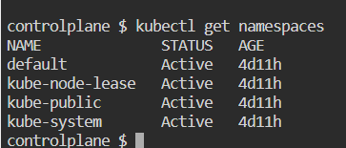

2-How many pods exist in the kube-system namespace?

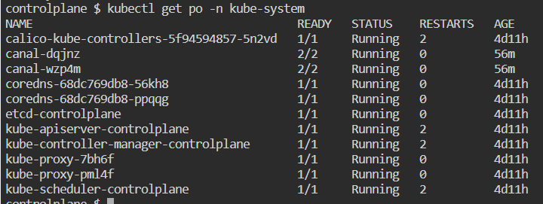

3- create a Deployment with

name= deployment-1

image= busybox

replicas= 3

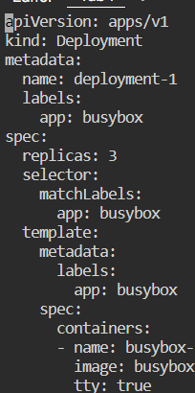 

4- How many Deployments and ReplicaSets exist on the system now?

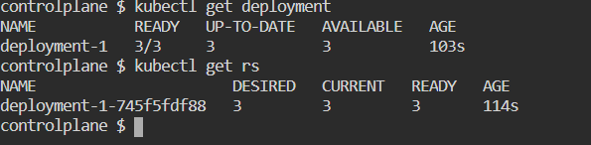

5- How many pods are ready with the deployment-1?

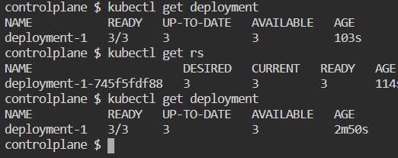

6- Update deployment-1 image to nginx then check the ready pods again

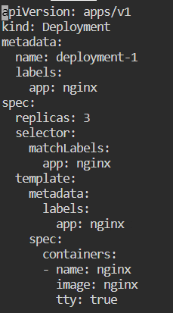

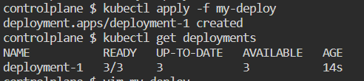

Or



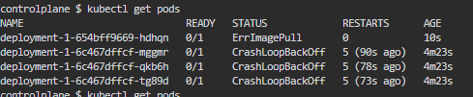

7- Run kubectl describe deployment deployment-1 and check events

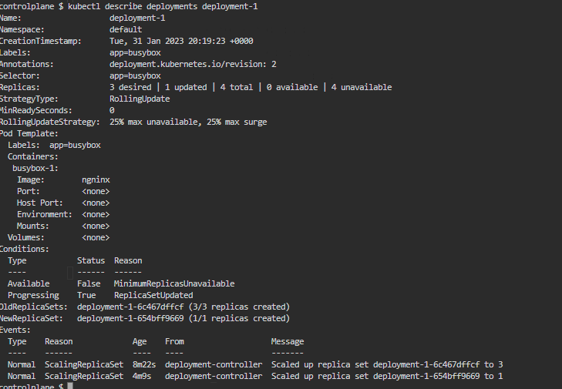

What is the deployment strategy used to upgrade the deployment-1? Rolling

8- Rollback the deployment-1



What is the used image with the deployment-1?



10- Create a deployment with

Name: dev-deploy

Image: redis

Replicas: 2

Namespace: dev

Resources Requests:

CPU: .5 vcpu

Mem: 1G

Resources Limits:

CPU: 1 vcpu

Mem: 2G

